Obs | imdb_score | color | director_name | language | num_dir
1 | 7.8 | Color | Tier 1 | English | 26
2 | 7.6 | Color | Tier 1 | English | 26
3 | 8.0 | Color | Tier 1 | English | 26
4 | 6.7 | Color | Tier 1 | English | 26
5 | 8.3 | Color | Tier 1 | English | 26
6 | 7.7 | Color | Tier 1 | English | 26
7 | 6.5 | Color | Tier 1 | English | 26
8 | 7.9 | Color | Tier 1 | English | 26
9 | 7.2 | Black an | Tier 1 | English | 26
10 | 8.1 | Color | Tier 1 | English | 26
11 | 7.6 | Color | Tier 1 | English | 26
12 | 8.5 | Color | Tier 1 | English | 26
13 | 7.3 | Color | Tier 1 | English | 26
14 | 7.4 | Color | Tier 1 | English | 26
15 | 8.9 | Black an | Tier 1 | English | 26

Obs | imdb_score | color | director_name | language | num_dir | newlanguage
1 | 7.8 | Color | Tier 1 | English | 26 | English
2 | 7.6 | Color | Tier 1 | English | 26 | English
3 | 8.0 | Color | Tier 1 | English | 26 | English
4 | 6.7 | Color | Tier 1 | English | 26 | English
5 | 8.3 | Color | Tier 1 | English | 26 | English
6 | 7.7 | Color | Tier 1 | English | 26 | English
7 | 6.5 | Color | Tier 1 | English | 26 | English
8 | 7.9 | Color | Tier 1 | English | 26 | English
9 | 7.2 | Black an | Tier 1 | English | 26 | English
10 | 8.1 | Color | Tier 1 | English | 26 | English
11 | 7.6 | Color | Tier 1 | English | 26 | English
12 | 8.5 | Color | Tier 1 | English | 26 | English
13 | 7.3 | Color | Tier 1 | English | 26 | English
14 | 7.4 | Color | Tier 1 | English | 26 | English
15 | 8.9 | Black an | Tier 1 | English | 26 | English
Since there are so many unique languages, I defined unique 6 major languages and defined rest of them as others.

Model Information
Data Set | WORK.IMDB
Distribution | Poisson
Link Function | Log
Dependent Variable | imdb_score

Criteria For Assessing Goodness Of Fit
Criterion | DF | Value | Value/DF
Deviance | 4912 | 925.1841 | 0.1884
Scaled Deviance | 4912 | 4912.0000 | 1.0000
Pearson Chi-Square | 4912 | 868.5429 | 0.1768
Scaled Pearson X2 | 4912 | 4611.2795 | 0.9388
Log Likelihood |  | 144466.5420
Full Log Likelihood |  | -9584.5236
AIC (smaller is better) |  | 19189.0471
AICC (smaller is better) |  | 19189.0919
BIC (smaller is better) |  | 19254.0618

Analysis Of Maximum Likelihood Parameter Estimates
Parameter |  | DF | Estimate | Standard  Error | Wald 95% Confidence Limits |  | Wald Chi-Square | Pr > ChiSq
Intercept |  | 1 | 2.0135 | 0.0120 | 1.9901 | 2.0370 | 28259.0 | <.0001
color | Color | 1 | -0.1147 | 0.0116 | -0.1374 | -0.0920 | 97.99 | <.0001
color | Black an | 0 | 0.0000 | 0.0000 | 0.0000 | 0.0000 | . | .
director_name | Tier 2 | 1 | -0.0452 | 0.0060 | -0.0569 | -0.0335 | 57.16 | <.0001
director_name | Tier 3 | 1 | -0.1118 | 0.0066 | -0.1249 | -0.0988 | 282.95 | <.0001
director_name | Tier 1 | 0 | 0.0000 | 0.0000 | 0.0000 | 0.0000 | . | .
newlanguage | French | 1 | 0.1292 | 0.0196 | 0.0909 | 0.1676 | 43.59 | <.0001
newlanguage | German | 1 | 0.1407 | 0.0370 | 0.0682 | 0.2132 | 14.48 | 0.0001
newlanguage | Hindi | 1 | 0.0811 | 0.0320 | 0.0183 | 0.1440 | 6.41 | 0.0113
newlanguage | Mandarin | 1 | 0.0472 | 0.0335 | -0.0184 | 0.1128 | 1.99 | 0.1584
newlanguage | Other | 1 | 0.1383 | 0.0141 | 0.1107 | 0.1659 | 96.54 | <.0001
newlanguage | Spanish | 1 | 0.1179 | 0.0262 | 0.0665 | 0.1693 | 20.19 | <.0001
newlanguage | English | 0 | 0.0000 | 0.0000 | 0.0000 | 0.0000 | . | .
Scale |  | 0 | 0.4340 | 0.0000 | 0.4340 | 0.4340

Note: | The scale parameter was estimated by the square root of DEVIANCE/DOF.

LR Statistics For Type 1 Analysis
Source | Deviance | Num DF | Den DF | F Value | Pr > F | Chi-Square | Pr > ChiSq
Intercept | 1018.7255
color | 998.2865 | 1 | 4912 | 108.52 | <.0001 | 108.52 | <.0001
director_name | 956.1833 | 2 | 4912 | 111.77 | <.0001 | 223.53 | <.0001
newlanguage | 925.1841 | 6 | 4912 | 27.43 | <.0001 | 164.58 | <.0001

LR Statistics For Type 3 Analysis
Source | Num DF | Den DF | F Value | Pr > F | Chi-Square | Pr > ChiSq
color | 1 | 4912 | 94.73 | <.0001 | 94.73 | <.0001
director_name | 2 | 4912 | 144.95 | <.0001 | 289.90 | <.0001
newlanguage | 6 | 4912 | 27.43 | <.0001 | 164.58 | <.0001
After estimating the scale, we can see that all of director name, color and some of newlanguage are significant. The baseline of this model is the first variable because it is the predominant variable in this model.Color is significantly different from black and white. For director name, Tier 2 and Tier 3 are significantly different from Tier 1.In newlanguage, French, Spanish, Hindi, German, and other languages are significantly different from English. Mandarin is insignificant.
Type 1 analysis indicates that all predictors are significant.Type 3 analysis has the same result as Type 1, it indicates that all predictors are significant. We are pretty sure that we keep the color variable but we need to see if we keep other variables as well.

Analysis Of Maximum Likelihood Parameter Estimates
Parameter |  | DF | Estimate | Standard  Error | Wald 95% Confidence Limits |  | Wald Chi-Square | Pr > ChiSq
Intercept |  | 1 | 2.0135 | 0.0120 | 1.9901 | 2.0370 | 28259.0 | <.0001
color | Color | 1 | -0.1147 | 0.0116 | -0.1374 | -0.0920 | 97.99 | <.0001
color | Black an | 0 | 0.0000 | 0.0000 | 0.0000 | 0.0000 | . | .
director_name | Tier 2 | 1 | -0.0452 | 0.0060 | -0.0569 | -0.0335 | 57.16 | <.0001
director_name | Tier 3 | 1 | -0.1118 | 0.0066 | -0.1249 | -0.0988 | 282.95 | <.0001
director_name | Tier 1 | 0 | 0.0000 | 0.0000 | 0.0000 | 0.0000 | . | .
newlanguage | French | 1 | 0.1292 | 0.0196 | 0.0909 | 0.1676 | 43.59 | <.0001
newlanguage | German | 1 | 0.1407 | 0.0370 | 0.0682 | 0.2132 | 14.48 | 0.0001
newlanguage | Hindi | 1 | 0.0811 | 0.0320 | 0.0183 | 0.1440 | 6.41 | 0.0113
newlanguage | Mandarin | 1 | 0.0472 | 0.0335 | -0.0184 | 0.1128 | 1.99 | 0.1584
newlanguage | Other | 1 | 0.1383 | 0.0141 | 0.1107 | 0.1659 | 96.54 | <.0001
newlanguage | Spanish | 1 | 0.1179 | 0.0262 | 0.0665 | 0.1693 | 20.19 | <.0001
newlanguage | English | 0 | 0.0000 | 0.0000 | 0.0000 | 0.0000 | . | .
Scale |  | 0 | 0.4340 | 0.0000 | 0.4340 | 0.4340

Note: | The scale parameter was estimated by the square root of DEVIANCE/DOF.
The parameter estimate of color is -0.1147 indicating an increase of one in color, imdb_score is expected to be increasing by e^-0.1147.and the parameter estimate of tier 2 is -0.0452 indicating an increase of one in tier2, imdb_score is expected to be increasing by e^-0.0452.and the parameter estimate of tier 3 is -0.1118 indicating an increase of one in tier3, imdb_score is expected to be increasing by e^-0.1118.the parameter estimate of French in newlanguage is 0.1292 indicating an increase of one in French, imdb_score is expected to be increasing by e^0.1292.the parameter estimate of Spanish in newlanguage is 0.1179 indicating an increase of one in Spanish, imdb_score is expected to be increasing by e^0.1179.the parameter estimate of German in newlanguage is 0.1407 indicating an increase of one in German, imdb_score is expected to be increasing by e^0.0.1407.the parameter estimate of Hindi in newlanguage is 0.0811 indicating an increase of one in Hindi, imdb_score is expected to be increasing by e^0.0811.the parameter estimate of other in newlanguage is 0.1383 indicating an increase of one in other, imdb_score is expected to be increasing by e^0.1383..

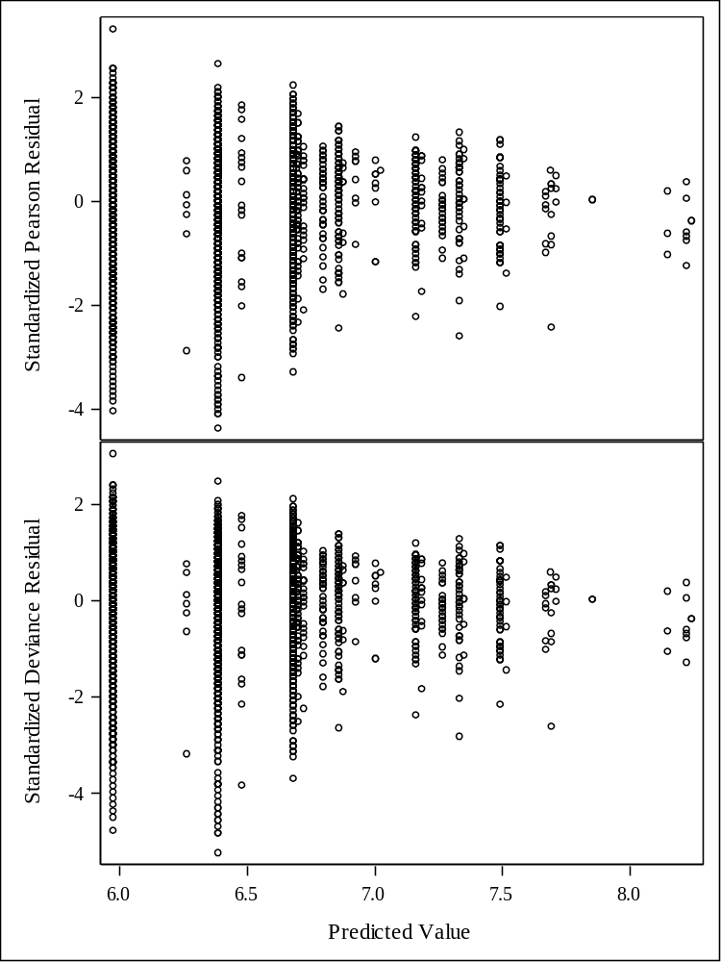
The scatter plot indicates that the residuals is narrowing as the predicted value increases. It is because first two predicted values have much more observations than last few values.I assumes this is why it has narrow trend.

Model Information
Data Set | WORK.IMDB
Distribution | Poisson
Link Function | Log
Dependent Variable | imdb_score

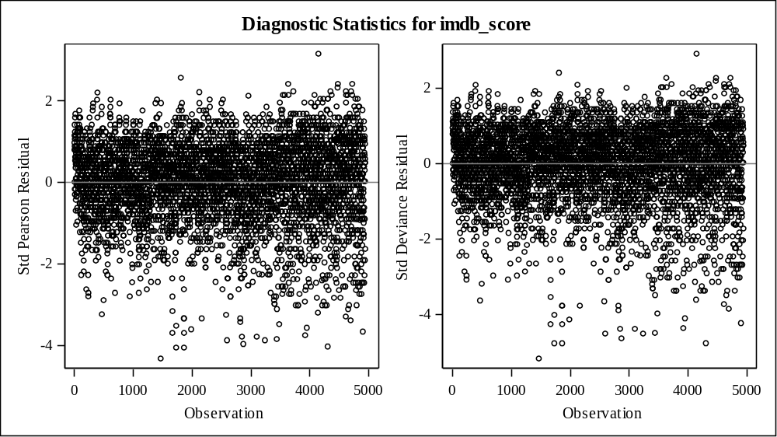
As we look at the diagnostic plot, the residuals are flat enough so the model is fine.

Model Information
Data Set | WORK.IMDB
Distribution | Gamma
Link Function | Log
Dependent Variable | imdb_score

Criteria For Assessing Goodness Of Fit
Criterion | DF | Value | Value/DF
Deviance | 4912 | 160.8283 | 0.0327
Scaled Deviance | 4912 | 4912.0000 | 1.0000
Pearson Chi-Square | 4912 | 137.5110 | 0.0280
Scaled Pearson X2 | 4912 | 4199.8451 | 0.8550
Log Likelihood |  | -7643.0117
Full Log Likelihood |  | -7643.0117
AIC (smaller is better) |  | 15306.0234
AICC (smaller is better) |  | 15306.0682
BIC (smaller is better) |  | 15371.0381

Analysis Of Maximum Likelihood Parameter Estimates
Parameter |  | DF | Estimate | Standard  Error | Wald 95% Confidence Limits |  | Wald Chi-Square | Pr > ChiSq
Intercept |  | 1 | 2.0149 | 0.0134 | 1.9887 | 2.0411 | 22703.4 | <.0001
color | Color | 1 | -0.1160 | 0.0129 | -0.1413 | -0.0906 | 80.44 | <.0001
color | Black an | 0 | 0.0000 | 0.0000 | 0.0000 | 0.0000 | . | .
director_name | Tier 2 | 1 | -0.0453 | 0.0064 | -0.0579 | -0.0328 | 50.08 | <.0001
director_name | Tier 3 | 1 | -0.1122 | 0.0070 | -0.1259 | -0.0985 | 256.20 | <.0001
director_name | Tier 1 | 0 | 0.0000 | 0.0000 | 0.0000 | 0.0000 | . | .
newlanguage | French | 1 | 0.1303 | 0.0216 | 0.0880 | 0.1726 | 36.41 | <.0001
newlanguage | German | 1 | 0.1402 | 0.0417 | 0.0584 | 0.2220 | 11.28 | 0.0008
newlanguage | Hindi | 1 | 0.0808 | 0.0344 | 0.0134 | 0.1482 | 5.51 | 0.0189
newlanguage | Mandarin | 1 | 0.0458 | 0.0363 | -0.0254 | 0.1170 | 1.59 | 0.2071
newlanguage | Other | 1 | 0.1395 | 0.0156 | 0.1089 | 0.1701 | 79.81 | <.0001
newlanguage | Spanish | 1 | 0.1185 | 0.0288 | 0.0620 | 0.1749 | 16.92 | <.0001
newlanguage | English | 0 | 0.0000 | 0.0000 | 0.0000 | 0.0000 | . | .
Scale |  | 0 | 30.5419 | 0.0000 | 30.5419 | 30.5419

Note: | The Gamma scale parameter was estimated by DOF/DEVIANCE.

LR Statistics For Type 1 Analysis
Source | Deviance | Num DF | Den DF | F Value | Pr > F | Chi-Square | Pr > ChiSq
Intercept | 175.3121
color | 172.2449 | 1 | 4912 | 93.68 | <.0001 | 93.68 | <.0001
director_name | 165.6468 | 2 | 4912 | 100.76 | <.0001 | 201.52 | <.0001
newlanguage | 160.8283 | 6 | 4912 | 24.53 | <.0001 | 147.17 | <.0001

LR Statistics For Type 3 Analysis
Source | Num DF | Den DF | F Value | Pr > F | Chi-Square | Pr > ChiSq
color | 1 | 4912 | 83.32 | <.0001 | 83.32 | <.0001
director_name | 2 | 4912 | 131.38 | <.0001 | 262.75 | <.0001
newlanguage | 6 | 4912 | 24.53 | <.0001 | 147.17 | <.0001
This time, I tried gamma distribution and the result is really similar to poisson distribution.After estimating the scale, we can see that all of director name, color and some of newlanguage are significant. The baseline of this model is the first variable because it is the predominant variable in this model.Color is significantly different from black and white. For director name, Tier 2 and Tier 3 are significantly different from Tier 1.In newlanguage, French, Spanish, Hindi, German, and other languages are significantly different from English. Only Mandarin is insignificant.
Type 1 analysis indicates that all predictors are significant.Type 3 analysis has the same result as Type 1, it indicates that all predictors are significant.

Analysis Of Maximum Likelihood Parameter Estimates
Parameter |  | DF | Estimate | Standard  Error | Wald 95% Confidence Limits |  | Wald Chi-Square | Pr > ChiSq
Intercept |  | 1 | 2.0149 | 0.0134 | 1.9887 | 2.0411 | 22703.4 | <.0001
color | Color | 1 | -0.1160 | 0.0129 | -0.1413 | -0.0906 | 80.44 | <.0001
color | Black an | 0 | 0.0000 | 0.0000 | 0.0000 | 0.0000 | . | .
director_name | Tier 2 | 1 | -0.0453 | 0.0064 | -0.0579 | -0.0328 | 50.08 | <.0001
director_name | Tier 3 | 1 | -0.1122 | 0.0070 | -0.1259 | -0.0985 | 256.20 | <.0001
director_name | Tier 1 | 0 | 0.0000 | 0.0000 | 0.0000 | 0.0000 | . | .
newlanguage | French | 1 | 0.1303 | 0.0216 | 0.0880 | 0.1726 | 36.41 | <.0001
newlanguage | German | 1 | 0.1402 | 0.0417 | 0.0584 | 0.2220 | 11.28 | 0.0008
newlanguage | Hindi | 1 | 0.0808 | 0.0344 | 0.0134 | 0.1482 | 5.51 | 0.0189
newlanguage | Mandarin | 1 | 0.0458 | 0.0363 | -0.0254 | 0.1170 | 1.59 | 0.2071
newlanguage | Other | 1 | 0.1395 | 0.0156 | 0.1089 | 0.1701 | 79.81 | <.0001
newlanguage | Spanish | 1 | 0.1185 | 0.0288 | 0.0620 | 0.1749 | 16.92 | <.0001
newlanguage | English | 0 | 0.0000 | 0.0000 | 0.0000 | 0.0000 | . | .
Scale |  | 0 | 30.5419 | 0.0000 | 30.5419 | 30.5419

Note: | The Gamma scale parameter was estimated by DOF/DEVIANCE.
The parameter estimate of color is -0.1160 indicating an increase of one in color, imdb_score is expected to be increasing by e^-0.1160.and the parameter estimate of tier 2 is -0.0453 indicating an increase of one in tier2, imdb_score is expected to be increasing by e^-0.0453.and the parameter estimate of tier 3 is -0.1122 indicating an increase of one in tier3, imdb_score is expected to be increasing by -0.1122 .the parameter estimate of French in newlanguage is 0.1303 indicating an increase of one in French, imdb_score is expected to be increasing by e^0.1303.the parameter estimate of Spanish in newlanguage is 0.1185 indicating an increase of one in Spanish, imdb_score is expected to be increasing by e^0.1185.the parameter estimate of German in newlanguage is 0.1402 indicating an increase of one in German, imdb_score is expected to be increasing by e^0.0.1402.the parameter estimate of Hindi in newlanguage is 0.0808 indicating an increase of one in Hindi, imdb_score is expected to be increasing by e^0.0808.the parameter estimate of other in newlanguage is 0.1395 indicating an increase of one in other, imdb_score is expected to be increasing by e^0.1395..

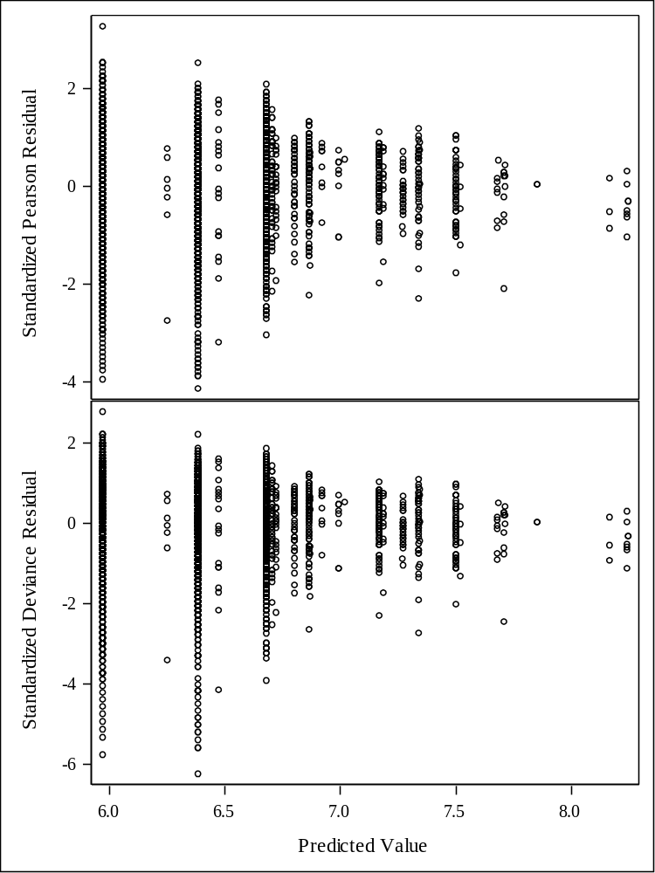
The scatter plot is also very similar to poisson distribution. it indicates that the residuals is narrowing as the predicted value increases. It is because first two predicted values have much more observations than last few values.I assumes this is why it has narrow trend.

Model Information
Data Set | WORK.IMDB
Distribution | Gamma
Link Function | Log
Dependent Variable | imdb_score

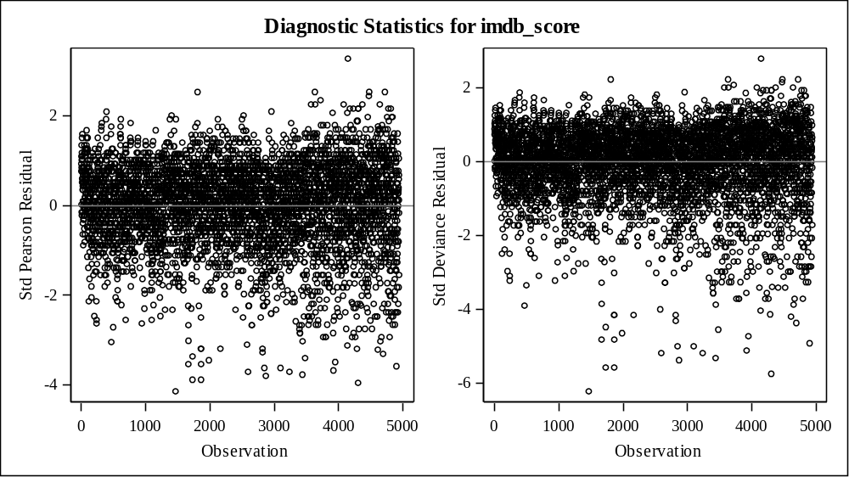
As we look at the diagnostic plot, the residuals are flat enough so the model is fine.

Number of Observations Read | 4939
Number of Observations Used | 4922
Missing Values | 17

Class Level Information
Class | Levels | Values
color | 2 | Black an Color
director_name | 3 | Tier 1 Tier 2 Tier 3
newlanguage | 7 | English French German Hindi Mandarin Other Spanish

Algorithm converged.

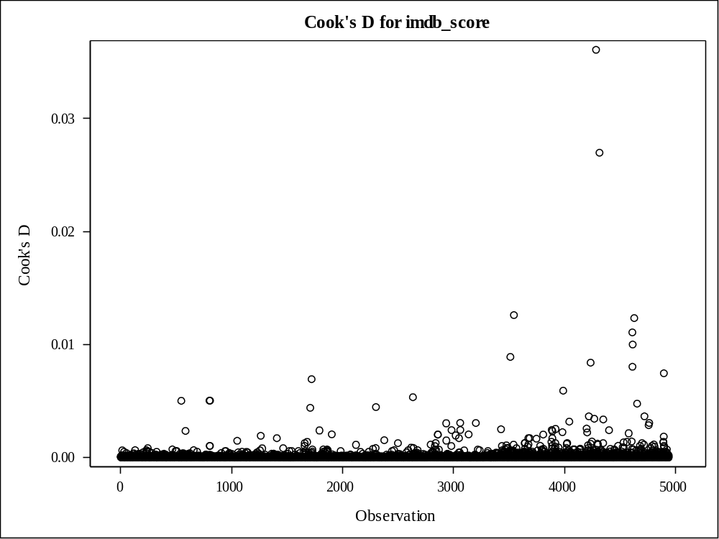
I chose to check if there is any influential points in model with gamma distribution. The reason I chose gamma distribution is because since I use continous variable as response variable, gamma distribution is better than poisson distribution which is appropriate for discret variable.As I checked cooks distance, there are some high influetial points compared to other points but it is not big enough to remove in terms of rule of thumb. so we can conclude there is no influential points this model.

